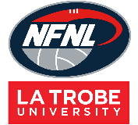
Northern Football Netball League
Under-9 and Under-10 Equipment Order Form - Season 2022
Club |  | Contact Name
Contact Email |  | Contact Number
Date Submitted |  | Date Required
NFNL Order Number (OFFICE USE ONLY)

Item | Price (inc GST) | Quantity
Portable Goals  (1 set includes 2 goal posts and 2 behinds posts) | $85.00
Ground Markers  (40 per set) | $61.00
Carry Bag | $35.00
Footballs  (Size 2 synthetic only) | $18.79
Wrist Bands  (24 pack – one colour) | $49.50 (Pack)  $2.30 (Individual)
Complete Kit  (Includes: 2 sets of goals, 1 set of markers, 1 carry bag, 2 Size 2 footballs and 1 set of wrist bands) | $330.00

Notes:
- Please email the completed form to Delwyn Berry at dberry@nfnl.org.au

