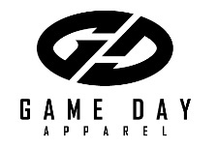
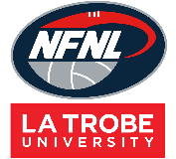
Northern Football Netball League
Netball Junior Uniform Order Form - Season 2023
Club |  | Contact Name
Contact Email |  | Contact Number
Date Submitted |  | Date Required
NFNL Order Number (OFFICE USE ONLY)
Collection Method: Please type here:
- Collect from Game Day |  | - Delivery (flat $35 courier fee)
Delivery address if applicable

A Line Dress Styles: Please type here:
Standard
$ 77.28 inc GST

A LINE DRESS | Size  6 | Size  8 | Size 10 | Size 12 | Size 14 | Size 16 | Size 18 | Size 20 | Size 22 | Size 24 | Size 26 | TOTAL
4 Piece w/ sides Standard
4 Piece w/ sides EL + 25mm
4 Piece w/ sides EL + 50mm
4 Piece w/ sides EL + 100mm
*EL – Extra Length

Netball T-Shirt (Unisex) | Price  inc GST | XS/6 | S/8 | M/10 | L/12 | XL/14 | 2XL/16 | TOTAL
No Velcro | $39.60
With Velcro | $43.45

BIBS INTERLOCK | Price  inc GST | QTY (SETS)
Bibs – Velcro (set of 7) | $100.54

Notes:
- Club logos require approval from the NFNL
- Colour matching must be completed before order is processed
- Order is NOT confirmed until club obtain receipt from the NFNL
- If delivery is selected, someone must be present at address to sign for goods
- Please allow up to six (6) weeks for production of your order
- Email completed forms to Delwyn Berry at dberry@nfnl.org.au

