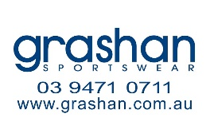
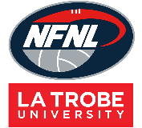
Northern Football Netball League
Netball Uniform Order Form - Season 2023
Club |  | Contact Name
Contact Email |  | Contact Number
Date Submitted |  | Date Required
NFNL Order Number (OFFICE USE ONLY)
Collection Method: Please type here:
- Collect from Grashan |  | - Delivery (flat $35 courier fee)
Delivery address if applicable

A LINE DRESS | Price inc GST | Size XS | Size S | Size M | Size L | Size XL | Size XXL | Other | TOTAL
4 Piece w/sides Standard | $79.20
4 Piece w/sides  EL + 25mm | $79.20
4 Piece w/sides  EL + 50mm | $79.20
4 Piece w/sides  EL + 100mm | $79.20
*EL – Extra Length

LYCRA BODY SUIT | Price inc GST | Size XS | Size S | Size M | Size L | Size XL | Size XXL | Other | TOTAL
4 Piece w/sides Standard | $97.90
4 Piece w/sides  EL + 25mm | $97.90
4 Piece w/sides  EL + 50mm | $97.90
4 Piece w/sides  EL + 100mm | $97.90

BIBS | Price inc GST | QTY (SETS)
Bibs (set of 7) | $99.55

Notes:
- Club logos require approval from the NFNL
- Colour matching must be completed before order is processed
- Order is NOT confirmed until club obtain receipt from the NFNL
- If delivery is selected, someone must be present at address to sign for goods
- Please allow up to six (6) weeks for production of your order
- Email completed forms to Delwyn Berry at dberry@nfnl.org.au

