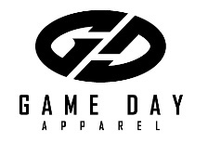
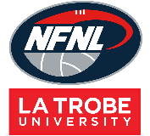
Northern Football Netball League
Socks Order Form - Season 2024
Club |  | Contact Name
Contact Email |  | Contact Number
Date Submitted |  | Date Required
NFNL Order Number (OFFICE USE ONLY)
Collection Method: Please type here:
- Collect from Game Day |  | - Delivery (flat $35 courier fee)
Delivery address if applicable
Style: Please type here:
Standard | Heritage | Themed Round
Theme type (if applicable)

Minimum Requirement :72 pairs per style at the price listed above below.

 | Price inc GST | 13-2 (S) | 2-7 (M) | 7-12 (L) | 12-14 (XL) | TOTAL
Short | $20.24
Long | $22.00
Elite Short | $24.64
Elite Long | $26.40
TOTAL
Minimum Requirement is 72 pairs per style at the price listed above in the table.

If you wish to purchase less than 72 pairs there will be an extra charge for $2.00 per pair, please place order in the table below

 | Price inc GST | 13-2 (S) | 2-7 (M) | 7-12 (L) | 12-14 (XL) | TOTAL
Short | $22.24
Long | $24.00
Elite Short | $26.64
Elite Long | $28.40
TOTAL

Notes:
- Order is NOT confirmed until club obtain receipt from the NFNL
- If delivery is selected, someone must be present at address to sign for goods.
- Please allow up to six (6) weeks for production of your order
- All socks will have the NFNL logo printed on them.
- Send completed forms to Kylie White at kwhite@nfnl.org.au

