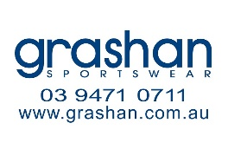
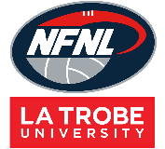
Northern Football Netball League
Netball Uniform Order Form - Season 2024
Club |  | Contact Name
Contact Email |  | Contact Number
Date Submitted |  | Date Required
NFNL Order Number (OFFICE USE ONLY)
Collection Method: Please type here:
- Collect from Grashan |  | - Delivery (flat $35 courier fee)
Delivery address if applicable
DRESSES
KIDS  A LINE DRESS  $78.32 inc GST | 6K | 8K | 10K | 12K | 14K | TOTAL
4 Piece w/sides Standard
4 Piece w/sides
EL + 25mm
4 Piece w/sides
EL + 50mm
4 Piece w/sides
EL + 100mm
*EL – Extra Length

WOMENS  A LINE DRESS  $81.84 inc GST | WMN XS | WMN S | WMN M | WMN L | WMN  XL | WMN  2XL | TOTAL
4 Piece w/sides Standard
4 Piece w/sides
EL + 25mm
4 Piece w/sides
EL + 50mm
4 Piece w/sides
EL + 100mm
*EL – Extra Length

NETBALL T- SHIRTS
KIDS  Netball T-Shirt (unisex) | Price inc GST | 6K | 8K | 10K | 12K | 14K | TOTAL
No Velcro | 42.24
With Velcro | 44.22

WOMENS Netball T-Shirt (unisex) | Price inc GST | WMN  XS | WMN  S | WMN  M | WMN  L | WMN  XL | WMN  2XL | TOTAL
No Velcro | 42.24
With Velcro | 44.22

UNDERSHORTS

Undershorts | Price  inc GST | 6K | 8K | 10K | 12K | 14K | XS | S | M | L | XL | 2XL | TOTAL
 | $42.90

BIBS

BIBS | Price inc GST | QTY (SETS)
Bibs (set of 7) | $100.10

Notes:
- Club logos require approval from the NFNL.
- Colour matching must be completed before order is processed.
- Order is NOT confirmed until club obtain receipt from the NFNL.
- If delivery is selected, someone must be present at address to sign for goods.
- Please allow up to six (6) weeks for production of your order
- Email completed forms to Kylie White at kwhite@nfnl.org.au

