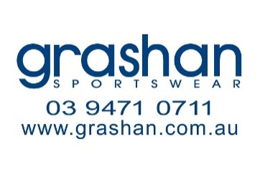
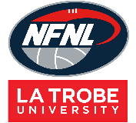
Northern Football Netball League
Socks Order Form - Season 2024
Club |  | Contact Name
Contact Email |  | Contact Number
Date Submitted |  | Date Required
NFNL Order Number (OFFICE USE ONLY)
Collection Method: Please type here:
- Collect from Grashan |  | - Delivery (flat $35 courier fee)
Delivery address if applicable
Style: Please type here:
Standard | Heritage | Themed Round
Theme type (if applicable)
Order:
 | Price inc GST | 9-2 (S) | 2-7 (M) | 7-12 (L) | 12-14 (XL) | TOTAL
Short | $17.60
Long | $17.60
Elite Short | $22.88
Elite Long | $22.00
TOTAL
Please note: Minimum order of 72 per style and 12 per size, per style.

Notes:
- Order is NOT confirmed until club obtain receipt from the NFNL
- If delivery is selected, someone must be present at address to sign for goods
- Please allow up to six (6) weeks for production of your order
- All socks will have the NFNL logo printed on them
- Send completed forms to Kylie White at kwhite@nfnl.org.au

