**Northern Football Netball League**

**Netball Uniform Order Form - Season 2024**

|  |  |  |  |
| --- | --- | --- | --- |
| **Club** |  | **Contact Name** |  |
| **Contact Email** |  | **Contact Number** |  |
| **Date Submitted** |  | **Date Required** |  |
| **NFNL Order Number (OFFICE USE ONLY)** | |  | |

**Collection Method:** *Please type here:*

|  |  |  |
| --- | --- | --- |
| 1. **Collect from Grashan** | | 1. **Delivery *(flat $35 courier fee)*** |
| Delivery address if applicable |  | |

**DRESS/T-Shirt Sponsor Details:** *Please note: Right chest is for NFNL logo only*

|  |  |  |  |
| --- | --- | --- | --- |
| Left Chest |  | Left Chest Sponsor or Club Logo |  |
| Back Above Bib |  | Back Below Bib |  |

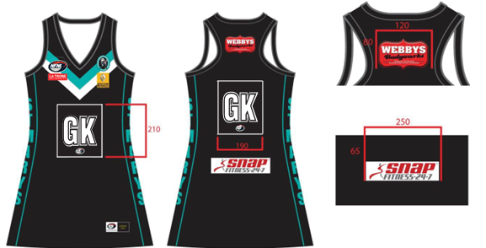**DRESSES**

|  |  |  |  |  |  |  |
| --- | --- | --- | --- | --- | --- | --- |
| **KIDS**  **A LINE DRESS**  **$78.32 inc GST** | 6K | 8K | 10K | 12K | 14K | TOTAL |
| 4 Piece w/sides Standard |  |  |  |  |  |  |
| 4 Piece w/sides  EL + 25mm |  |  |  |  |  |  |
| 4 Piece w/sides  EL + 50mm |  |  |  |  |  |  |
| 4 Piece w/sides  EL + 100mm |  |  |  |  |  |  |

*EL – Extra Length

|  |  |  |  |  |  |  |  |
| --- | --- | --- | --- | --- | --- | --- | --- |
| **WOMENS**  **A LINE DRESS**  **$81.84 inc GST** | WMN XS | WMN S | WMN M | WMN L | WMN  XL | WMN  2XL | TOTAL |
| 4 Piece w/sides Standard |  |  |  |  |  |  |  |
| 4 Piece w/sides  EL + 25mm |  |  |  |  |  |  |  |
| 4 Piece w/sides  EL + 50mm |  |  |  |  |  |  |  |
| 4 Piece w/sides  EL + 100mm |  |  |  |  |  |  |  |

*EL – Extra Length

**NETBALL T- SHIRTS**

|  |  |  |  |  |  |  |  |
| --- | --- | --- | --- | --- | --- | --- | --- |
| **KIDS**  **Netball T-Shirt (unisex)** | Price inc GST | 6K | 8K | 10K | 12K | 14K | TOTAL |
| No Velcro | 42.24 |  |  |  |  |  |  |
| With Velcro | 44.22 |  |  |  |  |  |  |

|  |  |  |  |  |  |  |  |  |
| --- | --- | --- | --- | --- | --- | --- | --- | --- |
| **WOMENS Netball T-Shirt (unisex)** | Price inc GST | WMN  XS | WMN  S | WMN  M | WMN  L | WMN  XL | WMN  2XL | TOTAL |
| No Velcro | 42.24 |  |  |  |  |  |  |  |
| With Velcro | 44.22 |  |  |  |  |  |  |  |

**UNDERSHORTS**

|  |  |  |  |  |  |  |  |  |  |  |  |  |  |
| --- | --- | --- | --- | --- | --- | --- | --- | --- | --- | --- | --- | --- | --- |
| **Undershorts** | Price  inc GST | 6K | 8K | 10K | 12K | 14K | XS | S | M | L | XL | 2XL | TOTAL |
|  | $42.90 |  |  |  |  |  |  |  |  |  |  |  |  |

**BIBS**

|  |  |  |  |  |  |
| --- | --- | --- | --- | --- | --- |
| **BIBS INTERLOCK** | Price  inc GST | QTY (SETS) | QTY (SETS) | QTY (SETS) | QTY (SETS) |
| Bibs | $100.10 |  |  |  |  |
| Colour Bib background |  |  |  |  |  |
| Colour Bib Positions |  |  |  |  |  |

**Notes:**

* Club logos require approval from the NFNL.
* Colour matching must be completed before order is processed.
* Order is NOT confirmed until club obtain receipt from the NFNL.
* If delivery is selected, someone must be present at address to sign for goods.
* Please allow up to six (6) weeks for production of your order
* Email completed forms to [officemanager@nfnl.org.au](mailto:officemanager@nfnl.org.au)