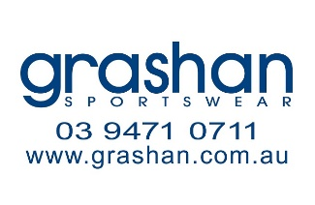
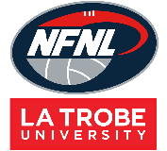
Northern Football Netball League
Shorts Order Form - Season 2024
Club |  | Contact Name
Contact Email |  | Contact Number
Date Submitted |  | Date Required
NFNL Order Number (OFFICE USE ONLY)
Collection Method: Please type here:
- Collect from Grashan |  | - Delivery (flat $35 courier fee)
Delivery address if applicable
Shorts Sponsor Details: Please note: Left leg front is for NFNL logo only
Right Leg Front

Order: SHORTS
MALE  STANDARD | Price  inc GST | 6 | 8 | 10 | 12 | 14 | XS | S | M | L | XL | 2XL | 3XL | 4XL | TOTAL
Home | $33.25
Away | $33.25

FEMALE  STANDARD* | Price  inc GST | 8 | 10 | 12 | 14 | XS | S | M | L | XL | 2XL | 3XL | Other | TOTAL
Home | $33.25
Away | $33.25
FEMALE  SCOOP LEG | Price  inc GST | 8 | 10 | 12 | 14 | XS | S | M | L | XL | 2XL | 3XL | Other | TOTAL
Home | $44.33
Away | $44.33
*Standard female shorts include a gusset
Notes:
- Club logos require approval from the NFNL
- Colour matching must be completed before order is processed
- Order is NOT confirmed until club obtain receipt from the NFNL
- If delivery is selected, someone must be present at address to sign for goods
- Please allow up to six (6) weeks for production of your order
- Send completed forms to officemanager@nfnl.org.au

