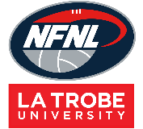

Netball DRESSES Order Form - Season 2026
CLUB |  | DATE SUBMITTED
CONTACT NAME |  | DATE REQUIRED
CONTACT EMAIL |  | REPEAT or NEW ORDER
CONTACT No. |  | NFNL Order Number (OFFICE USE ONLY) |  | #
COLLECTION METHOD (INCLUDE HERE OR HIGHLIGHT PREFERENCE)
- Collect from Belgravia - New Balance |  | - Delivery (flat $35 courier fee)
Delivery address if applicable
IF APPLICABLE DRESS SPONSOR DETAILS MUST BE COMPLETED NOTE: Right chest is for NFNL logo only
LEFT CHEST |  | LEFT CHEST Club Logo or 2nd Sponsor
BACK ABOVE BIB |  | BACK BELOW BIB

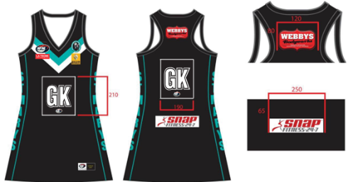
DRESSES – KIDS/YOUTH STANDARD FLATBACK SAMPLE DRESSES
STANDARD - BA  Flatback  $80.26 inc GST | Size 6 | Size 8 | Size 10 | Size 12 | Size 14 | Size 16 | TOTAL
Standard
EL +5cm
EL +10cm

DRESSES – ADULTS STANDARD FLATBACK
STANDARD - BA  Flatback  $80.26 inc GST | Size XS/8 | Size  S/10 | Size  M/12 | Size  L/14 | Size  XL/16 | Size  XXL/18 | Other | TOTAL
Standard
EL +5cm
EL +10cm

DRESSES – ADULTS ELITE NB SPEEDBACK
ELITE NB Speed back + extras GPS/Bra/Grippers  $103.05 includes GST | Size XS/8 | Size  S/10 | Size  M/12 | Size  L/14 | Size  XL/16 | Size  XXL/18 | Other | TOTAL
Standard
EL +5cm
EL +10cm

DRESSES – ADULTS ELITE SPEEDBACK
ELITE NB  Speed back  $100.24 includes GST | Size  XS/8 | Size  S/10 | Size  M/12 | Size  L/14 | Size  XL/16 | Size  XXL/18 | Other | TOTAL
Standard
EL +5cm
EL +10cm

Notes:
REPEAT ORDERS – Artwork already approved and no changes to logos/sponsors
NEW ORDER – Changes to design or/logos/sponsors NEW ARTWORK required

- Club logos/sponsors logos require approval from the NFNL in line with NFNL STYLE GUIDELINES – BY-LAWS SCHEDULE 22
- Clubs/Suppliers to complete colour matching /design before order is sent to be processed
- Order is NOT confirmed until club obtains NFNL official order number
- If delivery is selected, make arrangements for someone to be present at address to sign for goods
- Please allow up to six (6) weeks for production of your order
- Send completed forms to officemanager@nfnl.org.au

