
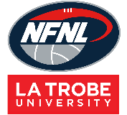
NETBALL BIBS ORDER FORM – SEASON 2026

CLUB |  | DATE SUBMITTED
CONTACT NAME |  | DATE REQUIRED
CONTACT EMAIL |  | REPEAT or NEW ORDER
CONTACT No. |  | NFNL Order Number (OFFICE USE ONLY) |  | #

COLLECTION METHOD (INCLUDE HERE OR HIGHLIGHT PREFERENCE)
- Collect from GAME DAY APPAREL |  | - Delivery (flat $35 courier fee)
Delivery address if applicable
BIBS INTERLOCK | Price  inc GST | QTY (SETS) | QTY (SETS) | QTY (SETS) | QTY (SETS)
Bibs Quantity (Sets) | $102.96
Colour Bib Background
Colour Bib Positions

BIBS ORDER

Please complete for each set - BIBS BACKGROUND COLOUR and BIBS POSITION LETTER COLOUR
REPEAT ORDERS – Artwork already approved and no changes to logos/sponsors
NEW ORDER – Changes to design/logos/sponsors NEW ARTWORK required

SAMPLE BIBS

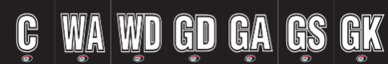

Notes:

- Club logos/sponsors logos require approval from the NFNL in line with NFNL STYLE GUIDELINES – BY-LAWS SCHEDULE 22
- Clubs/Suppliers to complete colour matching /design before order is sent to be processed
- Order is NOT confirmed until club obtains NFNL official order number
- If delivery is selected, make arrangements for someone to be present at address to sign for goods
- Please allow up to six (6) weeks for production of your order
- Send completed forms to officemanager@nfnl.org.au

