

Netball DRESSES Order Form - Season 2026
CLUB |  | DATE SUBMITTED
CONTACT NAME |  | DATE REQUIRED
CONTACT EMAIL |  | REPEAT or NEW ORDER
CONTACT No. |  | NFNL Order Number (OFFICE USE ONLY)
COLLECTION METHOD (INCLUDE HERE OR HIGHLIGHT PREFERENCE)
- Collect from GAME DAY APPAREL |  | - Delivery (flat $35 courier fee)
Delivery address if applicable
IF APPLICABLE DRESS SPONSOR DETAILS MUST BE COMPLETED NOTE: Right chest is for NFNL logo only
LEFT CHEST |  | LEFT CHEST Club Logo or 2nd Sponsor
BACK ABOVE BIB |  | BACK BELOW BIB
DRESSES
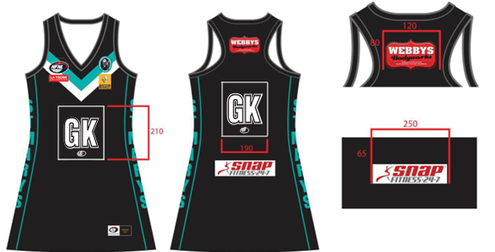
SAMPLE NETBALL DRESS
KIDS  A LINE DRESS  $82.72 inc GST | KIDS  SIZE  4 | KIDS  SIZE  6 | KIDS  SIZE  8 | KIDS  SIZE  10 | KIDS  SIZE  12 | KIDS  SIZE  14 | TOTAL
4 Piece w/ sides Standard
4 Piece w/ sides EL + 25mm
4 Piece w/ sides EL + 50mm
4 Piece w/ sides EL + 100mm

*EL – Extra Length
WOMENS  A LINE DRESS  $82.72 inc GST | WNS  SIZE  6 | WNS  SIZE  8 | WNS  SIZE  10 | WNS  SIZE  12 | WNS  SIZE  14 | WNS  SIZE  16 | WNS  SIZE  18 | WNS  SIZE  20 | WNS  SIZE  22 | WNS  SIZE  24 | WNS  SIZE  26 | TOTAL
4 Piece w/ sides Standard
4 Piece w/ sides EL + 25mm
4 Piece w/ sides EL + 50mm
4 Piece w/ sides EL + 100mm

*EL – Extra Length
WOMENS ELITE  A LINE DRESS  $105.71 inc GST | WNS  SIZE  6 | WNS  SIZE  8 | WNS  SIZE  10 | WNS  SIZE  12 | WNS  SIZE  14 | WNS  SIZE  16 | WNS  SIZE  18 | WNS  SIZE  20 | WNS  SIZE  22 | WNS  SIZE  24 | WNS  SIZE  26 | TOTAL
4 Piece w/ sides Standard
4 Piece w/ sides EL + 25mm
4 Piece w/ sides EL + 50mm
4 Piece w/ sides EL + 100mm
*EL – Extra Length

Notes:
REPEAT ORDERS – Artwork already approved and no changes to logos/sponsors
NEW ORDER – Changes to design or/logos/sponsors NEW ARTWORK required

- Club logos/sponsors logos require approval from the NFNL in line with NFNL STYLE GUIDELINES – BY-LAWS SCHEDULE 22
- Clubs/Suppliers to complete colour matching /design before order is sent to be processed
- Order is NOT confirmed until club obtains NFNL official order number
- If delivery is selected, make arrangements for someone to be present at address to sign for goods
- Please allow up to six (6) weeks for production of your order
Send completed forms to officemanager@nfnl.org.au

