
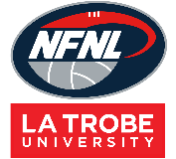
Netball Bibs Order Form - Season 2026

CLUB |  | DATE SUBMITTED
CONTACT NAME |  | DATE REQUIRED
CONTACT EMAIL |  | REPEAT or NEW ORDER
CONTACT No. |  | NFNL Order Number (OFFICE USE ONLY) |  | #
COLLECTION METHOD (INCLUDE HERE OR HIGHLIGHT PREFERENCE)
- Collect from GRASHAN |  | - Delivery (flat $35 courier fee)
Delivery address if applicable

DRESS Sponsor Details: MUST BE COMPLETED RIGHT CHEST is for NFNL logo only
Left Chest |  | Left Chest Sponsor or Club Logo
Back Above Bib |  | Back Below Bib
BIBS INTERLOCK | Price  inc GST | QTY (SETS) | QTY (SETS) | QTY (SETS) | QTY (SETS)
Bibs Quantity (Sets) | $105.82
Colour Bib Background
Colour Bib Positions

BIBS ORDER
Please complete for each BIB set BACKGROUND COLOUR and POSITION LETTER COLOUR

BIBS SAMPLE
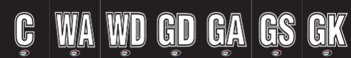

REPEAT ORDERS – Artwork already approved and no changes to logos/sponsors
NEW ORDER – Changes to design/logos/sponsors NEW ARTWORK required

Notes:

- Club logos/sponsors logos require approval from the NFNL in line with NFNL STYLE GUIDELINES – BY-LAWS SCHEDULE 22
- Clubs/Suppliers to complete colour matching /design before order is sent to be processed
- Order is NOT confirmed until club obtains NFNL official order number
- If delivery is selected, make arrangements for someone to be present at address to sign for goods
- Please allow up to six (6) weeks for production of your order
- Send completed forms to officemanager@nfnl.org.au

