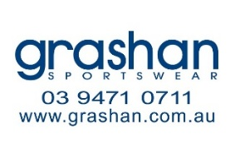
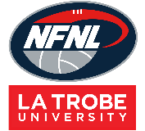
Shorts Order Form - Season 2026

CLUB |  | DATE SUBMITTED
CONTACT NAME |  | DATE REQUIRED
CONTACT EMAIL |  | REPEAT or NEW ORDER
CONTACT No. |  | NFNL Order Number (OFFICE USE ONLY) |  | #
COLLECTION METHOD (INCLUDE HERE OR HIGHLIGHT PREFERENCE)
- Collect from GRASHAN |  | - Delivery (flat $35 courier fee)
Delivery address if applicable
SHORTS SPONSOR DETAILS: MUST BE COMPLETED Please note: LEFT LEG FRONT is for NFNL logo only
RIGHT LEG FRONT

ORDER:
STANDARD SHORTS
MALE  STANDARD | Price  inc GST | 6 | 8 | 10 | 12 | 14 | XS | S | M | L | XL | 2XL | 3XL | 4XL | TOTAL
Home | $35.81
Away | $35.81

FEMALE  STANDARD* | Price  inc GST | 8 | 10 | 12 | 14 | XS | S | M | L | XL | 2XL | 3XL | Other | TOTAL
Home | $35.81
Away | $35.81
*Standard female shorts include a gusset

FEMALE SCOOP
FEMALE  SCOOP | Price  inc GST | 8 | 10 | 12 | 14 | XS | S | M | L | XL | 2XL | 3XL | Other | TOTAL
Home | $48.59
Away | $48.59

REPEAT ORDERS – Artwork already approved and no changes to logos/sponsors
NEW ORDER – Changes to design/logos/sponsors NEW ARTWORK required

Notes:
- Club logos/sponsors logos require approval from the NFNL in line with NFNL STYLE GUIDELINES – BY-LAWS SCHEDULE 22
- Clubs/Suppliers to complete colour matching /design before order is sent to be processed
- Order is NOT confirmed until club obtains NFNL official order number
- If delivery is selected, make arrangements for someone to be present at address to sign for goods
- Please allow up to six (6) weeks for production of your order
- Send completed forms to officemanager@nfnl.org.au

