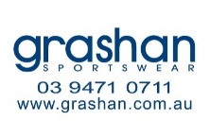
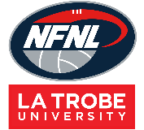
Socks Order Form - Season 2026

CLUB |  | DATE SUBMITTED
CONTACT NAME |  | DATE REQUIRED
CONTACT EMAIL |  | REPEAT or NEW ORDER
CONTACT No. |  | NFNL Order Number (OFFICE USE ONLY) |  | #

COLLECTION METHOD (INCLUDE HERE OR HIGHLIGHT PREFERENCE)
- Collect from GRASHAN |  | - Delivery (flat $35 courier fee)
Delivery address if applicable

STYLE: PLEASE TYPE HERE OR HIGHLIGHT BELOW
Standard | Heritage | Themed Round
Theme type (if applicable)

ORDER:
*** Please Note – each SOCK STYLE minimum order 72 pairs and 12 pairs per size***

SOCK STYLE | Price inc GST | 9-2 (S) | 2-7 (M) | 7-12 (L) | 12-14 (XL) | TOTAL QTY
STANDARD - SHORT | $19.36
STANDARD - LONG | $19.71
ELITE – SHORT | $25.52
ELITE – LONG | $24.64
TOTAL QTY

Notes:

- Club logos/sponsors logos require approval from the NFNL in line with NFNL STYLE GUIDELINES – BY-LAWS SCHEDULE 22
- Clubs/Suppliers to complete colour matching /design before order is sent to be processed
- Order is NOT confirmed until club obtains NFNL official order number
- If delivery is selected, make arrangements for someone to be present at address to sign for goods
- Please allow up to six (6) weeks for production of your order
- Send completed forms to officemanager@nfnl.org.au

