

Netball T/SHIRT & SHORTS Order Form - Season 2026

CLUB |  | DATE SUBMITTED
CONTACT NAME |  | DATE REQUIRED
CONTACT EMAIL |  | REPEAT or NEW ORDER
CONTACT No. |  | NFNL Order Number (OFFICE USE ONLY) |  | #
COLLECTION METHOD (INCLUDE HERE OR HIGHLIGHT PREFERENCE)
- Collect from Belgravia - New Balance |  | - Delivery (flat $35 courier fee)
Delivery address if applicable
IF APPLICABLE T/SHIRT SPONSOR DETAILS MUST BE COMPLETED NOTE: Right chest is for NFNL logo only
LEFT CHEST |  | LEFT CHEST Club Logo or 2nd Sponsor
BACK ABOVE BIB |  | BACK BELOW BIB

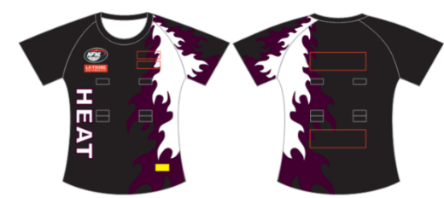
NETBALL T SHIRTS – KIDS/YOUTH
SAMPLE T-SHIRT
Netball T-Shirt  Standard (Unisex) | Price  inc GST | Size 6 | Size 8 | Size 10 | Size 12 | Size 14 | TOTAL
No Velcro | $43.52
With Velcro | $47.87

NETBALL T SHIRTS – ADULTS STANDARD
Netball T-Shirt  Standard (Unisex) | Price  inc GST | Size  XS/8 | Size  S/10 | Size  M/12 | Size  L/14 | Size  XL/16 | Size  2XL/18 | Other | TOTAL
No Velcro | $43.52
With Velcro | $47.87

NETBALL T SHIRTS – ADULTS ELITE
Netball T-Shirt  Elite  (Womens) | Price  inc GST | Size  XS/8 | Size  S/10 | Size  M/12 | Size  L/14 | Size  XL/16 | Size  2XL/18 | Other | TOTAL
No Velcro | $49.61
With Velcro | $52.22
REPEAT ORDERS – Artwork already approved and no changes to logos/sponsors
NEW ORDER – Changes to design or/logos/sponsors NEW ARTWORK required
UNDERSHORTS – KIDS/YOUTH
UNDERSHORTS  (Nicks) | Price inc GST | Size  8 | Size  10 | Size  12 | Size  14 | TOTAL
Standard | $40.80

UNDERSHORTS – ADULTS
UNDERSHORTS  (Nicks) | Price inc GST | Size  XS/8 | Size  S/10 | Size  M/12 | Size  L/14 | Size  XL/16 | Size  XXL/18 | Other | TOTAL
Standard | $40.80
Elite | $44.06

Notes:

- Club logos/sponsors logos require approval from the NFNL in line with NFNL STYLE GUIDELINES – BY-LAWS SCHEDULE 22
- Clubs/Suppliers to complete colour matching /design before order is sent to be processed
- Order is NOT confirmed until club obtains NFNL official order number
- If delivery is selected, make arrangements for someone to be present at address to sign for goods
- Please allow up to six (6) weeks for production of your order
- Send completed forms to officemanager@nfnl.org.au

