

Netball T-SHIRT and SHORTS Order Form - Season 2026
CLUB |  | DATE SUBMITTED
CONTACT NAME |  | DATE REQUIRED
CONTACT EMAIL |  | REPEAT or NEW ORDER
CONTACT No. |  | NFNL Order Number (OFFICE USE ONLY)
COLLECTION METHOD (INCLUDE HERE OR HIGHLIGHT PREFERENCE)
- Collect from GAME DAY APPAREL |  | - Delivery (flat $35 courier fee)
Delivery address if applicable
IF APPLICABLE DRESS SPONSOR DETAILS MUST BE COMPLETED NOTE: Right chest is for NFNL logo only
LEFT CHEST |  | LEFT CHEST Club Logo or 2nd Sponsor
BACK ABOVE BIB |  | BACK BELOW BIB

NETBALL T SHIRTS

KIDS  Netball T-Shirt (Unisex) | Price  inc GST | KIDS  SIZE  4 | KIDS  SIZE  6 | KIDS  SIZE  8 | KIDS  SIZE  10 | KIDS  SIZE  12 | KIDS  SIZE  14 | TOTAL QTY
No Velcro | $42.24
With Velcro | $47.52

WOMENS Netball T-Shirt (Unisex) | Price  inc GST | WNS  SIZE  12 | WNS  SIZE  14 | WNS  SIZE  16 | WNS  SIZE  18 | WNS  SIZE  20 | WNS  SIZE  22 | TOTAL QTY
No Velcro | $42.24
With Velcro | $47.52

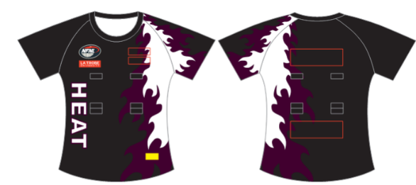
SAMPLE T-SHIRTS
REPEAT ORDERS – Artwork already approved and no changes to logos/sponsors
NEW ORDER – Changes to design or/logos/sponsors NEW ARTWORK required

UNDERSHORTS

KIDS UNDERSHORTS | Price  inc GST | KIDS  KIDS  4 | KIDS  SIZE  6 | KIDS  SIZE  8 | KIDS  SIZE  10 | KIDS  SIZE  12 | KIDS  SIZE  14 | TOTAL
Standard | $40.10
Elite | $47.52

WOMENS UNDERSHORTS | Price  inc GST | WNS  SIZE  8 | WNS  SIZE  10 | WNS  SIZE  12 | WNS  SIZE  14 | WNS  SIZE  16 | WNS  SIZE  18 | TOTAL
Standard | $40.10
Elite | $47.52

NETBALL SHORTS

UNISEX SHORTS | Price  inc GST | 6 | 8 | 10 | 12 | 14 | S | M | L | XL | 2XL | 3XL | 4XL | 5XL | TOTAL QTY
Standard | $35.64

NETBALL SHORT SIZING
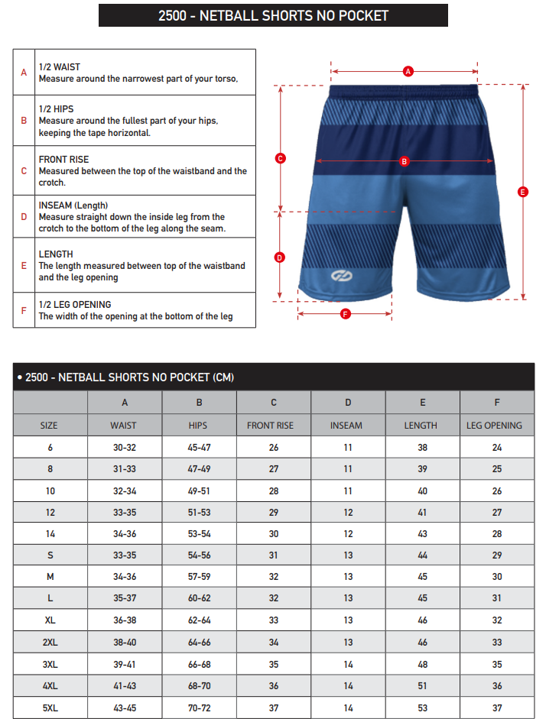

Notes:

- Club logos/sponsors logos require approval from the NFNL in line with NFNL STYLE GUIDELINES – BY-LAWS SCHEDULE 22
- Clubs/Suppliers to complete colour matching /design before order is sent to be processed
- Order is NOT confirmed until club obtains NFNL official order number
- If delivery is selected, make arrangements for someone to be present at address to sign for goods
- Please allow up to six (6) weeks for production of your order
Send completed forms to officemanager@nfnl.org.au

