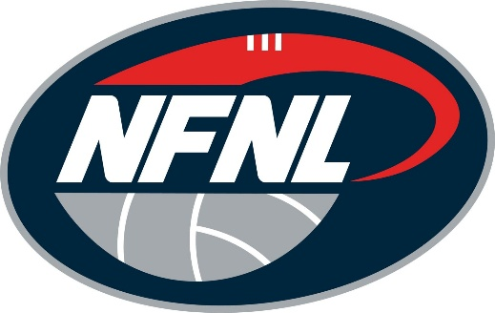
NFNL TRIBUNAL VERDICT: JUNE 13-14, 2026
PLAYER/OFFICIAL | CLUB | CHARGE | OUTCOME
ANDREW OLIVER | DIAMOND CREEK | MISCONDUCT | 6 MATCHES
LUCAS CHESSWAS | KILMORE | ROUGH CONDUCT | 2 MATCHES

