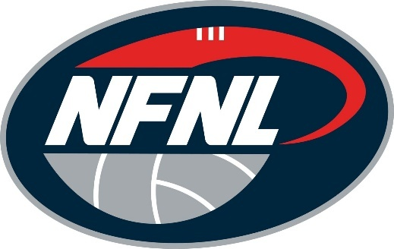
NFNL TRIBUNAL VERDICT: JUNE 20-21, 2026
PLAYER/OFFICIAL | CLUB | CHARGE | OUTCOME
Jai Bartzis | Watsonia | Set Penalty | 2 MATCHES
Isaac Baldwin | Montmorency | ROUGH CONDUCT | 2 MATCHES

