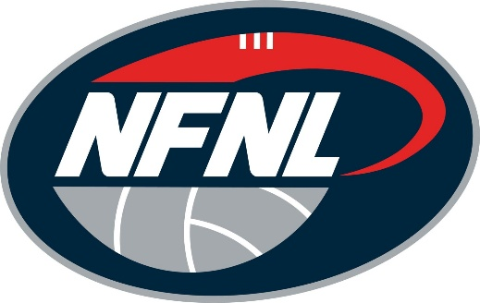
NFNL TRIBUNAL VERDICT: JUNE 6-7, 2026
PLAYER/OFFICIAL | CLUB | CHARGE | OUTCOME
NICK KOSMAS | RESERVOIR | SERIOUS MISCONDUCT | APPEAL - 4 MATCHES

